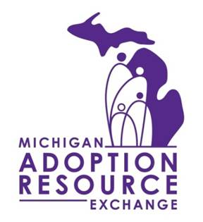
MATCH SUPPORT PROGRAM
REFERRAL FORM

Family Information:
Name/s: |  | Has Family Signed Intent to Adopt:  ☐ Yes ☐ No
Street Address, City, Zip:

Phone Number: | Email Address:
Family’s Adoption Worker Name: | Agency:
Agency Street Address, City, Zip:

Worker Phone Number: | Worker Email Address:
Type of Match:  ☐ Recruited Family ☐ Youth’s Current Foster Family ☐ Relative |  | Date of Match:

MARE Matched Youth Information:
Name: | C#: |  | Was Youth Ever Photolisted on MARE:  ☐ Yes ☐ No
Child’s Adoption Worker Name: |  | Agency:
Agency Street Address, City, Zip:

Adoption Worker Phone Number: |  | Adoption Worker Email Address:
Foster Care Worker Name: |  | Foster Care Worker Agency or MDHHS:
Foster Care Worker Phone Number: |  | Foster Care Worker Email Address:

Referrer Information:
Name: | Title/Role:
Phone Number, if not included above: | Email Address, if not included above:

For questions or additional information, please contact Match Support Program Supervisor,
Julie Miller, at 734-528-2002 or Julie_Miller@judsoncenter.org.

