Barbara Jean’s Tours and Cruises

Presents A

Put-n-bay Getaway

Saturday June 18-Sunday June 19, 2016

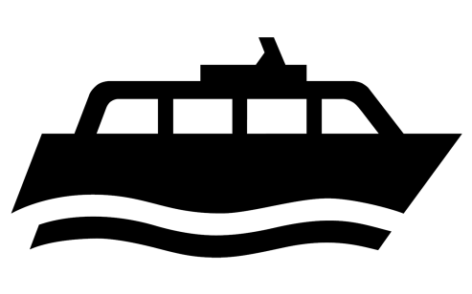

$190 per person (2people per room)

$50 nonrefundable due 3/12/16, $50 4/12,5/12, balance due 6/1/16

Pack your bag and getaway for 2Days/1nite of exploring an Island in the Sun, walk on the beach, shop, eat and see sights of Put-n-bay, Ohio.

Round trip transportation, lodging and ferry included. Call Veda 313 532-0012 for further information.

Name_________________________Address_____________________

City/zip_____________Cell/phone#s____________________________

Roommate_______________________Amount Paid______