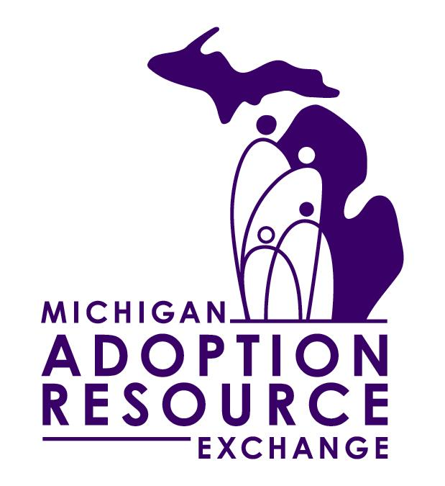
The Michigan Adoption Resource Exchange
needs you for our youth advisory board,
Adoption Leaders of Today (ALT)!

MARE is looking for youth aged 12-22 who:
- Are currently waiting to be adopted
- Have been adopted
- Aged-out of care waiting to be adopted

Joining Adoption Leaders of Today (ALT) is a great way for youth to meet other youth who are in similar situations as themselves. ALT members help to improve Michigan’s adoption and foster care systems by creating recruitment activities and media campaigns and giving their opinions on policy and programs. ALT members will receive leadership, communication, and team building experience in a safe environment with other like-minded youth and young adults.

Meeting places will rotate around the state to give members from all over the chance to attend. Youth unable to attend or participate will also be sent meeting minutes after each monthly meeting to keep them up-to-date on projects and news.

ALT members will be compensated for giving their opinions and attending a few meetings a year. Youth will receive gift cards for each meeting they attend, with the amount increasing the more meetings they come to! Travel expenses will be paid by MARE.

Interested?
Fill out the forms on the following pages and send to:
MARE
c/o Jen Dickey
P.O. Box 980789
Ypsilanti, MI 48197
OR Fax: 734.528.1695
Questions? Jennifer_dickey@judsoncenter.org
734.528.2064 x 23236 / 1.800.589.MARE
Michigan Adoption Resource Exchange
Adoption Leaders of Today
Print Youth Application

Date: ______________

Name of Youth: |  |  |  |  |  |  |  | Birth Date: Current Age:
Gender: |  |  |  |  |  | Race:
What kind of living arrangement are you in?  (Check one) | Foster Care |  | Relative Placement |  | Pre-adoption Placement |  |  |  | Adoptive Family |  |  | Residential Placement | Independent Living
Address:
Address 2:
City: |  |  |  | County: |  |  |  |  |  |  | Zip Code:
Phone #: |  |  |  |  |  |  | Alt Phone #:
Email:
Best way to contact you?
Name of Caregiver(s):
Phone #: |  |  |  |  |  |  | Alt Phone #:
Email:
Primary Worker
Name: |  |  |  |  | Type of Worker:
Agency: |  |  |  |  |  |  |  |  |  | Phone #:
Address:
Address 2:
City: |  | State: |  |  |  |  |  | Zip Code:
Email:
Secondary Worker
Name: |  |  |  |  | Type of Worker:
Agency: |  |  |  |  |  |  |  |  |  | Phone #:
Address:
Address 2:
City: |  | State: |  |  |  |  |  | Zip Code:
Email:
Is youth currently, or was in the past, listed on the MARE website? Y N C #:

Are youth currently in school? Y N |  |  | If yes, name of school:
Grade/Year: |  |  | Area of study:
Does youth have a job? Y N |  |  | If yes, name of employer:
How many hours per week do youth work?
What time of day is youth available for meetings? | Monday  to | Tuesday  to |  | Wednesday  to | Thursday  to | Friday  to | Saturday  to | Sunday  to
Other, please explain:

Signature of Youth ____________________________________________ Date _________________

Michigan Adoption Resource Exchange
Adoption Leaders of Today

Caregiver Commitment of Support
Parent, Legal Guardian, Foster Parent,
Relative, Residential Caseworker

Name of Youth: __ ____________ _____ Age: ___________

The Michigan Adoption Resource Exchange youth advisory board, ALT, allows youth aged 12-22 throughout the state of Michigan a chance to voice their concerns and desired changes for the foster care and adoption systems. Youth will participate in leadership, effective communication, and team building activities in a safe environment designed to offer them a chance to work with other like-minded youth who are in similar situations. Youth will brainstorm ideas for media campaigns and recruitment activities and other adoption-related tasks to increase the general knowledge of adoption throughout the state.

Youth will be required to attend monthly meetings (when possible) and participate fully when in attendance. Selected youth will also participate in bi-monthly Adoption Oversight Committee meetings with adoption professionals throughout the state. By signing this Commitment of Support, I am acknowledging that the youth named above will have my support as a caregiver to participate in this extracurricular activity and I will do everything in my power to encourage their participation. I recognize that it is my responsibility to provide transportation and if other transportation is necessary will contact MARE staff or DHS/POS workers. I acknowledge that the youth will not receive cash payments as incentives and that any incentives given belong to the youth themselves as a compensation for participating.

The above youth meets the eligibility criteria and hereby has my permission and support to participate in the MARE ALT. My signature below certifies that I am a parent, legal guardian, foster parent, relative, or residential caseworker of the named youth and that I consent to their participation in ALT.

Name of Caregiver: __ ________________

Relationship to Participant: __ __________

Phone Number: _ ______________________ Alt Phone:__________________

Email Address: ___________________________________________________

Signature: ______________________________________ Date:___________
Michigan Adoption Resource Exchange
Adoption Leaders of Today

Worker Commitment of Support
DHS/POS Worker

Name of Youth: ______ ____________ ____ Age: ______

The Michigan Adoption Resource Exchange youth advisory board, ALT, allows youth aged 12-22 throughout the state of Michigan a chance to voice their concerns and desired changes for the foster care and adoption systems. Youth will participate in leadership, effective communication, and team building activities in a safe environment designed to offer them a chance to work with other like-minded youth who are in similar situations. Youth will brainstorm ideas for media campaigns and recruitment activities and other adoption-related activities to increase the general knowledge of adoption throughout the state.

Youth will be required to attend monthly meetings (when possible) and participate fully when in attendance. Selected youth will also participate in bi-monthly Adoption Oversight Committee meetings with adoption professionals throughout the state. By signing this Commitment of Support, I am acknowledging that the youth named above will have my support as a worker to participate in this extracurricular activity and I will do everything in my power to encourage their participation. I recognize that it is the responsibility of the caregiver to provide transportation and if other transportation is necessary I will contact MARE staff. I acknowledge that the youth will not receive cash payments as incentives and that any incentives given belong to the youth themselves as a compensation for participating.

The above youth meets the eligibility criteria and hereby has my permission and support to participate in the MARE ALT. My signature below certifies that I am a DHS/POS worker for the named youth and that I consent to their participation in ALT.

Name of Worker: __________________________________________________

Type of Worker: __________________Phone Number: ___________________

Agency: _________________________________________________________

Email Address: ___________________________________________________

Signature: ______________________________________ Date:___________

