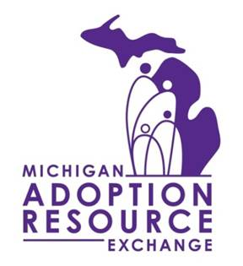
MATCH SUPPORT PROGRAM
REFERRAL FORM

Michigan Adoption Resource Exchange

Family Information:
Family Name: |  | Email:
Address (street number and name):
City: | State: MI | Zip code: | Phone Number:

Family’s Adoption Worker:
Name: |  | Email:
Agency Name and Address:
City: | State: MI | Zip code: | Phone Number:

MARE Matched Child Information:
Name: |  |  | C#:
Child’s Adoption Worker Name: |  | Email:
Agency Name and Address:
City: | State: MI |  | Zip code: | Phone Number:

Date of Match:

Type of Match (Foster, Relative or Recruited Family):

Has the Intent to Adopt form been signed (Yes or No)?

If No, please explain the circumstances that is preventing this.

Who is making this referral?

